# ZOROPERGAMON EMPIRE

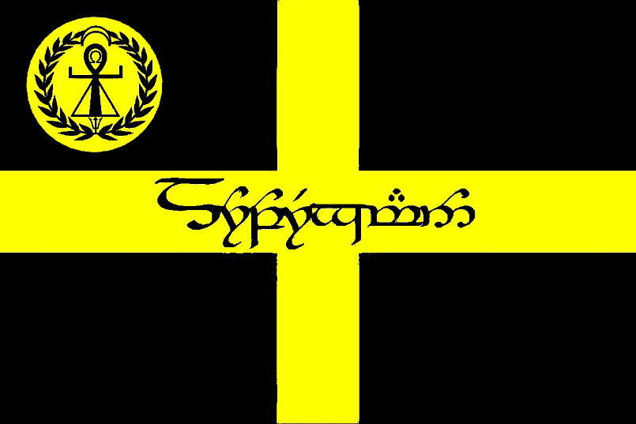

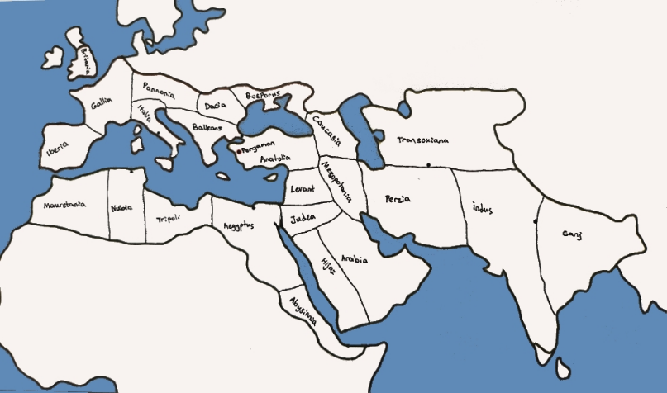

**The Birth of the Zoropergamon Empire**

The year was 717, and the siege of Pergamon had lasted for months. The city, once a shining jewel of Anatolia, stood on the brink of collapse under the relentless assault of the Umayyad forces. The Dabuyid dynasty, holding on to the last remnants of their Persian legacy, found itself desperate for salvation. Just when hope seemed lost, the banners of the Oghuz tribes appeared on the horizon, led by their formidable khan, Tulug Bey.

The arrival of the Oghuz warriors turned the tide of the battle. With their swift cavalry and unyielding discipline, they struck the besieging forces with an unmatched fury, breaking their lines and forcing them into a hasty retreat. Pergamon was saved, and in the aftermath of the battle, a new alliance was forged—one that would change the course of history.

Tulug Bey, a visionary leader, understood that the world was shifting. The Arab expansion threatened both the Turkic steppe warriors and the remnants of Persian power. He saw an opportunity to unite disparate peoples under a single banner, one that would blend the strength of the steppes with the wisdom of Persian administration and the strategic knowledge of Hellenic and Anatolian cultures.

The Dabuyid rulers, indebted to Tulug Bey for their survival, proposed an unprecedented arrangement. Instead of mere tribute or vassalage, they offered a true partnership—an empire where Turks, Persians, and Anatolians would stand as equals. The Oghuz, fascinated by the teachings and traditions of Zoroastrianism, found in the Dabuyids an opportunity to learn about the ancient faith, its fire temples, and its emphasis on truth and order. Inspired by these ideas, they sought to weave them into their own traditions, strengthening their spiritual and philosophical foundations. Tulug Bey accepted the proposal, and thus, the Zoropergamon Empire was born.

Taking the title of Sheshinkhan, Tulug Bey established a vast and unprecedented dominion that stretched across three continents. He divided his empire into three major regions: Europe, Asia, and Africa, each governed by Eyalets and Satrapies that balanced local autonomy with imperial unity. He ensured that diverse cultures thrived under his rule, creating a fusion of traditions, knowledge, and military tactics that made the Zoropergamon Empire the most formidable force the world had ever seen.

Tulug Bey’s reign as the first Sheshinkhan was marked by expansion, reform, and consolidation. He established a powerful administrative system that blended Persian bureaucracy with Turkic pragmatism, built trade networks that connected the empire from the Atlantic to the Indian Ocean, and fostered a unique cultural renaissance where Greek philosophy, Persian poetry, and Turkic epics were celebrated in the grand cities of the empire.

Though his reign eventually ended, Tulug Bey’s legacy endured. The Zoropergamon Empire became a beacon of strength, culture, and innovation, standing as a testament to the power of unity forged in the fires of war. The name of Sheshinkhan would be carried by his successors, but it was Tulug Bey who had laid the foundation for the greatest empire the world had ever known.

Overview of the Zoropergamon Empire

The Zoropergamon Empire stands as one of the largest and most powerful empires in history, forged by an unprecedented alliance between the Oghuz Turks and the Dabuyid Dynasty. Spanning continents and embracing diverse cultures, it is an empire built on military prowess, administrative genius, and a blend of religious and cultural traditions.

Emperor’s Title: The emperor of Zoropergamon is known as Sheshinkhan, a title combining the Persian "Shahanshah" (King of Kings) and the Turkic "Khagan" (Great Khan), symbolizing the fusion of Persian imperial authority and Turkic leadership.

Capital: The heart of the empire is Pergamon, strategically located in Anatolia (modern-day Turkey), a city that blends Persian, Greek, and local Anatolian influences. Pergamon serves not only as a political and administrative center but also as a symbol of the empire’s hybrid nature.

Flag: The flag of the Zoropergamon Empire features a black and yellow cross, representing the unity between the various cultures within the empire. In the upper left corner, there may be symbols or ancient writing that signify the merging of Zoroastrian, Turkic, and Greek influences, reflecting the cultural melting pot that the empire is.

Government Structure

The government of the Zoropergamon Empire is a complex system that fuses Persian imperial governance, Turkic tribal leadership, and Byzantine administrative practices. This allows the empire to govern vast territories efficiently while maintaining a strong central authority.

Sheshinkhan (Emperor): As the supreme ruler, Sheshinkhan holds absolute authority over the empire’s military, legal system, and administration. His title signifies the unity of Persian and Turkic traditions, and he governs with the aid of the Divan-i Zoropergamon (Imperial Council), a body of military leaders, governors, and advisors who help manage the empire's diverse regions.

Divan-i Zoropergamon (Imperial Council): The council is made up of key figures from the military, administrative, and religious sectors of the empire. It includes powerful Satrap-Khans (regional governors), military commanders, and high-ranking religious leaders. The council plays a vital role in advising the emperor on crucial matters such as military campaigns, legal reforms, and governance policies.

Military System

The Zoropergamon military, known as the Qızıl Ordusu (Golden Army), is a highly diverse and efficient fighting force that incorporates Oghuz cavalry, Persian infantry, and Greek engineering. The military’s strength lies in its adaptability to various terrains and its ability to unite the best elements from each culture within the empire.

Oghuz Cavalry: The Oghuz Turks are renowned for their horse archery and swift cavalry tactics. Their cavalry serves as the backbone of the empire’s military, excelling in hit-and-run raids, skirmishes, and large-scale battles.

Persian Heavy Infantry: Modeled after the legendary Immortals of the Persian Empire, the heavy infantry of Zoropergamon are well-trained and heavily armored, often forming the central force in sieges and defensive battles.

Greek & Roman Engineers: The empire incorporates Greek and Roman siege engineering, allowing for advanced siege tactics and the construction of fortifications. Engineers skilled in building bridges, war machines, and siege towers are invaluable during military campaigns.

Arab & Berber Light Troops: Skilled in desert warfare and rapid raids, the Arab and Berber forces add versatility to the empire’s military capabilities, particularly in regions like North Africa and the Arabian Peninsula.

Naval Forces: With control over critical Mediterranean and Arabian Sea trade routes, Zoropergamon boasts a powerful navy. Drawing inspiration from Byzantine naval traditions, the empire’s fleet excels in both commerce and warfare, enabling it to defend against pirates and wage naval campaigns.

Law & Religion

The Zoropergamon Empire is known for its religious tolerance and its ability to merge multiple belief systems into a cohesive, functioning society. Religion plays a significant role in both governance and daily life.

The Three-Faith Code: The empire’s legal system is deeply intertwined with its religious diversity. The Three-Faith Code incorporates three main belief systems:

Zoroastrianism: Rooted in the traditions of the Dabuyid Dynasty, Zoroastrianism influences both the moral and legal codes of the empire, particularly in areas such as justice, cleanliness, and the divine right of rulers.

Tengrism: The Turkic belief in a sky god and the veneration of ancestors continues to hold sway, especially among the nomadic tribes of the empire. These traditions influence the empire’s military ethos and tribal governance.

Greek-Roman Paganism & Christianity: The empire is home to a rich mix of Greek-Roman pagan traditions, including the worship of deities like Apollo, as well as Christianity, which is still practiced in regions with strong Byzantine heritage, particularly in Europe and the Mediterranean.

Law: The legal system of Zoropergamon is an intricate blend of Persian imperial law, Turkic steppe traditions, and Byzantine legal codes. This hybrid system allows the empire to manage diverse regions efficiently while respecting local customs. The legal structure emphasizes central authority, fairness, and a blend of customary laws with imperial decrees.

Economy & Infrastructure

The economy of the Zoropergamon Empire is one of the most advanced in the ancient world, benefiting from its strategic position at the crossroads of East and West. Its economy thrives on agriculture, trade, and industry, allowing it to sustain its vast population and military.

Trade & Agriculture: The empire controls important trade routes, including those along the Silk Road and the Mediterranean. It exports luxury goods such as spices, silk, and textiles, while importing valuable resources like silver, horses, and precious metals. Agricultural regions in Persia, Anatolia, and Egypt provide vital crops, including grain, olives, and cotton.

Industry: Zoropergamon is known for its advanced craftsmanship in areas like metalwork, weaponry, and textile production. These industries are bolstered by the empire's ability to draw from Persian artisans, Turkic practicality, and Greek artistic traditions.

Infrastructure: The empire boasts an impressive network of roads, bridges, and fortresses, allowing for the smooth movement of goods, troops, and information. The Roman road system is extensively repaired and expanded, while new cities and trade hubs are built to connect distant regions of the empire. The construction of aqueducts, palaces, and temples in various regions showcases the empire’s engineering prowess.

Cultural Fusion

Zoropergamon is a vibrant cultural hub where the Persian, Turkic, and Greek heritages merge into a unique civilization. This fusion influences every aspect of daily life, from the arts and architecture to philosophy and cuisine.

Art & Architecture: The empire’s architectural style blends Persian palaces, Greek temples, and Turkic nomadic designs. The use of columns, arches, and domes in architecture reflects Greek and Persian influences, while steppe motifs adorn palaces and city walls.

Language: The empire’s official language is a blend of Persian, Turkic, and Greek, used for diplomacy, trade, and governance. In regions with a strong cultural identity, local languages are still spoken, but they incorporate words and phrases from the imperial tongue.

Philosophy & Science: The empire is a center of learning, where Greek philosophers, Persian scientists, and Turkic warriors exchange ideas. Advances in mathematics, astronomy, and medicine are shared between scholars, resulting in breakthroughs that influence later civilizations.